# Lecture 1: Intro to Programming & Flowcharts



03 January 2022 15:26

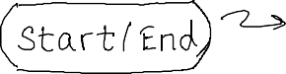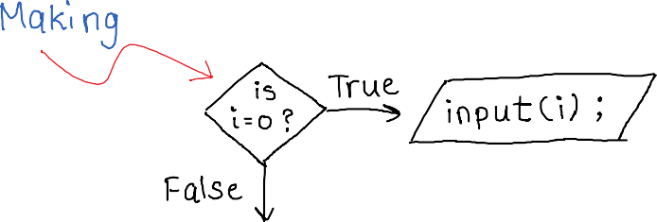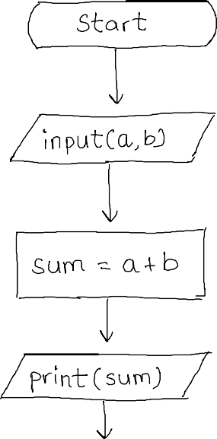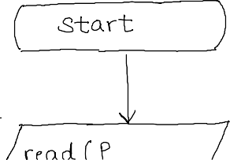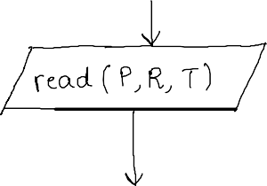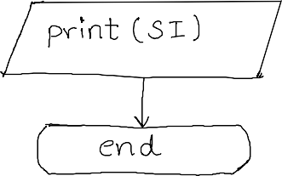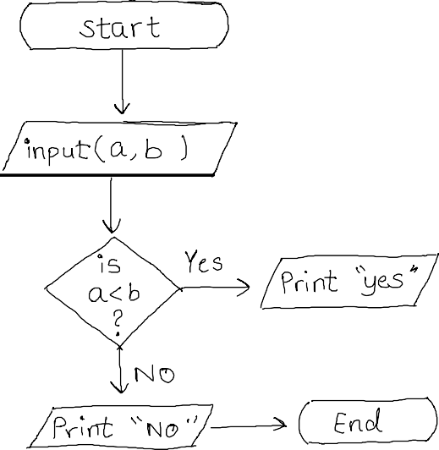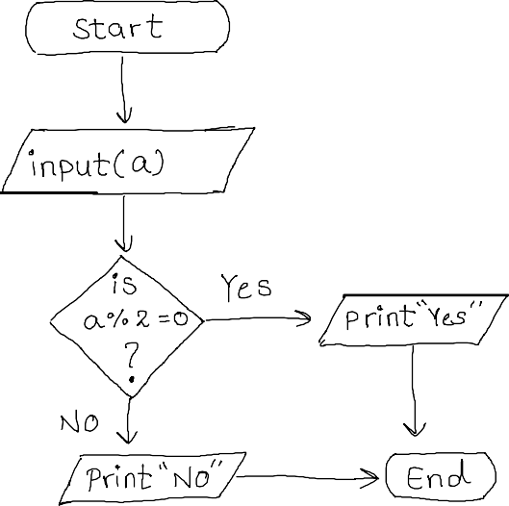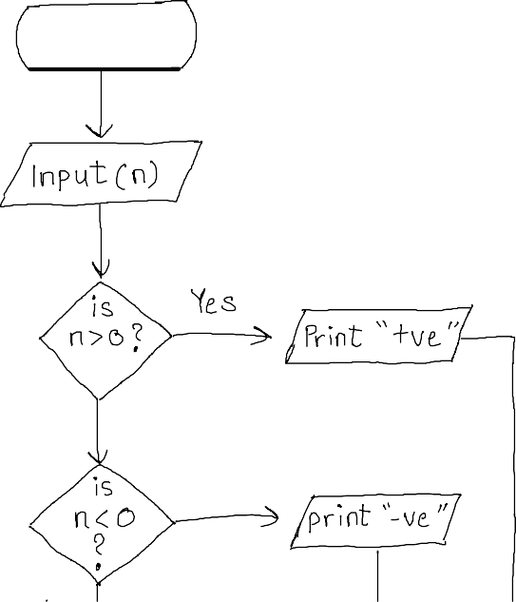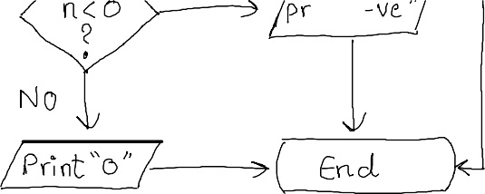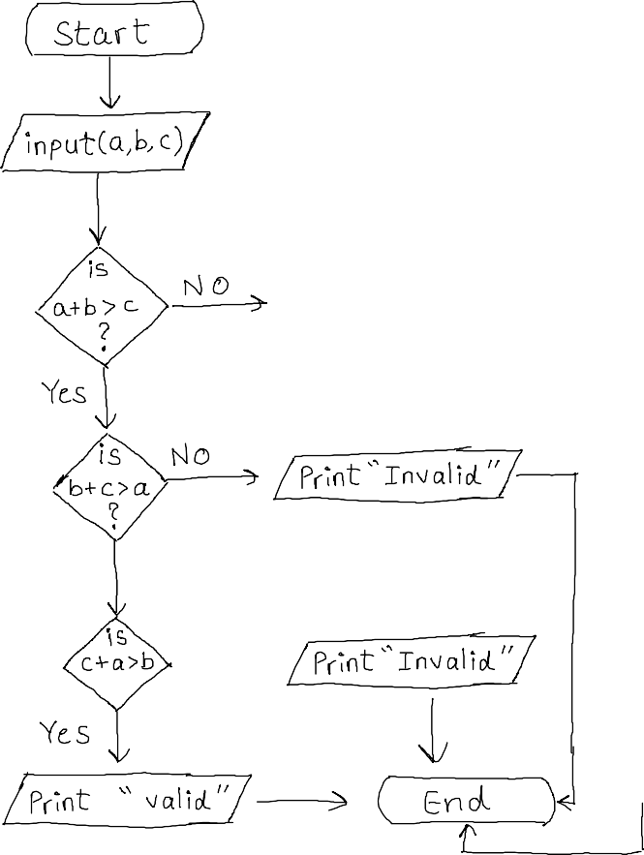

Loops

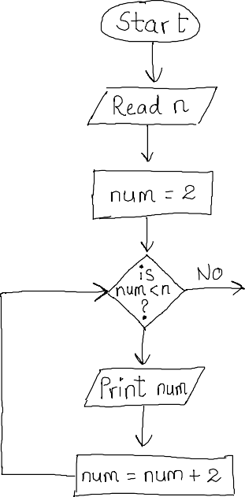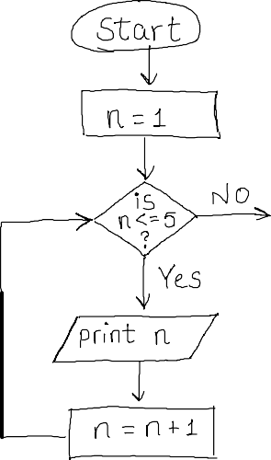

03 January 2022



17:39

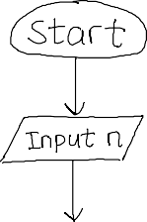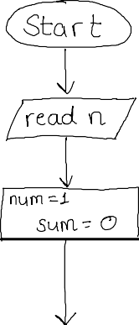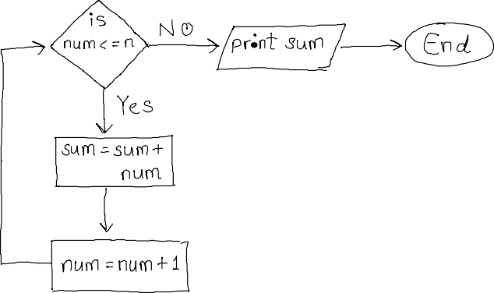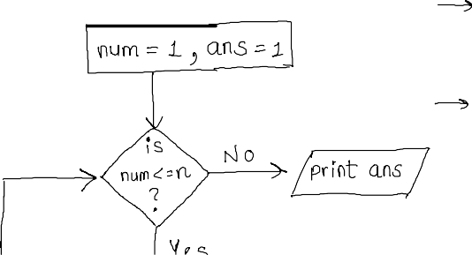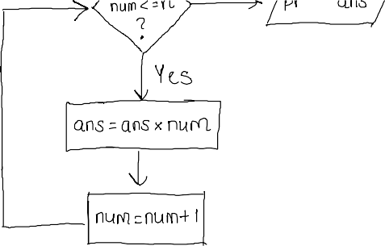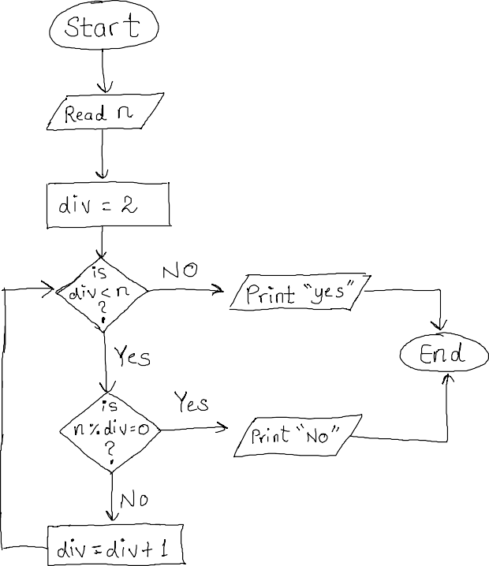

# Programming Language

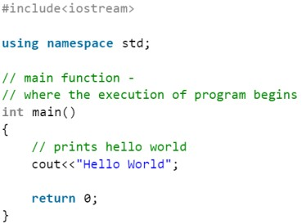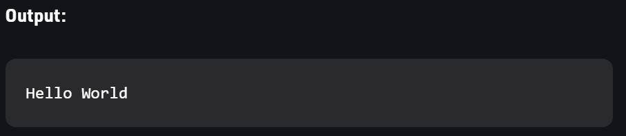

03 January 2022 18:33



<https://www.geeksforgeeks.org/writing-first-c-program-hello-world-example/>



Program For Odd Number

// Online C++ compiler to run C++ program online

#include <iostream>

using namespace std;

int main() {

int num;

cout<<"Enter number"<<endl;

cin>>num;

for(int i=1;i<=num;i=i+2)

{

    if(i%2!=0)

    {

        cout<<i<<endl;

    }

}

    return 0;

}

Program For Factorial using Iterative Method

// Online C++ compiler to run C++ program online

#include <iostream>

using namespace std;

int main()

{

int num,sum=1;

cout<<"Enter number"<<endl;

cin>>num;

for(int i=2;i<=num;i++)

{

    sum=sum*i;



}

cout<<sum<<endl;



return 0;

}